

**TÀI LIỆU KẾT NỐI SERVICE ALIPAY**

**I. Mục đích:**

1.Tài liệu mô tả service phục vụ tạo ra mã QRCODE

**II. Mô tả services**

Webservice sử dụng: https://paymentuat.tpb.vn/GatewayService/services/EBGProcessor?wsdl

**III.**Dịch Vụ Pre-Create

**1. Mô tả request:**

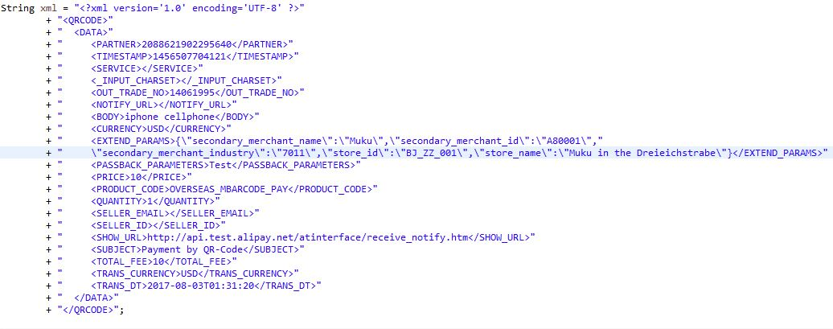

|  |  |  |  |  |
| --- | --- | --- | --- | --- |
| **STT** | **THAM SỐ** | **GIÁ TRỊ** | **BẮT BUỘC** | **CHÚ THÍCH** |
| **1** | XREF | (String) | Y | Mã giao dịch do QPAY sinh ra duy nhất, không trùng lặp (trong ngày), phục vụ đối  soát dữ liệu (Có thể trùng lặp với XREF ở trong nội dung bản tin XML) |
| **2** | User | QRCODE | Y | User của QPAY trên hệ thống của TPBank |
| **3** | Password | EB146 | Y | Password của QPAY trên hệ thống của TPBank |
| **4** | Code | QR-ALP-CREATE | Y | Mã xử lý |
| **5** | requestData | Mô tả chi tiết bên dưới |  | Miêu tả các tham số ở dưới |
| **5.1** | PARTNER | 2088621902295640 | Y | Unique Alipay user number corresponding to authorized Alipay account number.  Composed of 16 numbers beginning with 2088. |
| **5.2** | SERVICE | alipay.acquire.precreate | Y | Interface name |
| **5.3** | TIMESTAMP | 1456507704121 | Y | Time stamp of the merchant server sending request, accurate to the millisecond. |
| **5.4** | _INPUT_CHARSET | UTF-8 | Y | Encoding format used in merchant’s website, such as  utf-8, gbk, gb2312, etc |
| **5.6** | OUT_TRADE_NO | 99003911198989 | Y | Unique order ID in Alipay’s merchant website |
| **5.7** | NOTIFY_URL | http://api.test.alipay.net/atinterface/receive_notify.htm | N | Alipay server takes the initiative to notify merchant of webpage http path designated by website. |
| **5.8** | CURRENCY | USD | Y | Settlement currency.  Currency and trans_currency cannot be different foreign currency. |
| **5.9** | BODY | iphone cellphone | N | Specific description of the trade. In case of a variety of goods, please accumulate the character strings descrbing the goods, and transmit the same to body. |
| **5.10** | EXTEND_PARAMS | {"store_id":"BJ_ZZ_001","store_name":"Muku in the Dreieichstrabe","secondary_merchant_id":"A80001","secondary_merchant_name":"Muku","secondary_merchant_industry":"7011"} | Y | This parameter contains extended parameters of the request, and transmits business information of the merchant. Format: JSON. For details |
| **5.10.1** | secondary_merchant_name | Muku | Y | Secondary merchant name. Can be null only in cross-border agency acquiring mode and the name is verified. |
| **5.10.2** | secondary_merchant_id | A80001 | Y | Secondary merchant ID, must be passed. |
| **5.10.3** | secondary_merchant_industry | 7011 | Y | For MCC code definitions |
| **5.10.4** | store_id | BJ_ZZ_001 | Y | Store ID, must be passed. |
| **5.10.5** | store_name | Muku in the Dreieichstrabe | Y | Store name. Can be null only when the store information is verified. |
| **5.11** | PASSBACK_PARAMETERS | Test | N | If merchant transfer this parameter by the request string, Alipay will feedback this parameter by the asynchronous notify (parameter name: extra_common_param). |
| **5.12** | PRICE | 10 | N | Unit price of the goods in the order. If this parameter is transmitted at request, the condition of total_fee=price×quantity must be met. |
| **5.13** | PRODUCT_CODE | OVERSEAS_MBARCODE_PAY | Y | Order placement used to distinguish the business type:  ?   OVERSEAS_MBARCODE_PAY: face to face payment overseas |
| **5.14** | QUANTITY | 10 | N | Quantity of the goods in the order. If this parameter is transmitted at request, the condition of total_fee=price×quantity must be met. |
| **5.16** | SELLER_EMAIL | test@alitest.com | N | Seller’s Alipay account, may be email or phone number  If seller_id is not null, the value of seller_id shall be the seller’s ID and this parameter can be neglected. |
| **5.17** | SELLER_ID | 2088101106499364 | N | Unique Alipay user ID corresponding to Seller’s Alipay account  16 numbers beginning with 2088.  If both sell_id and seller-email are null, the default value of this parameter to be filled out shall be the value of merchant. |
| **5.18** | SHOW_URL | http://www.taobao.com/product/113714.html | N | Hyperlink for the show of goods on the webpage of checkout counter. |
| **5.19** | SUBJECT | Payment by QR-Code | Y | Goods title/trade tile/order subject/order key word etc.  The length of this parameter is up to 128 Chinese characters. |
| **5.20** | TOTAL_FEE | 10 | Y | Total fee of this order. The range of values is [0.01, 100000000], such value can have up to two digits after the decimal point. |
| **5.21** | TRANS_CURRENCY | USD | Y | Pricing currency for the transaction, if it is not CNY, the CNY amount user will be charged will be calculated based on trans_currency and exchange rate. |

**2. Mô tả respone:**

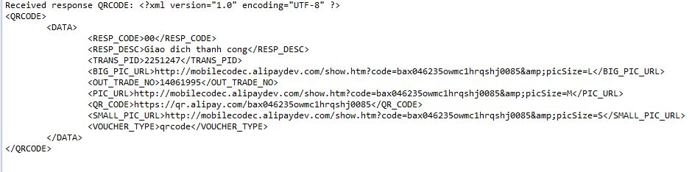

|  |  |  |  |
| --- | --- | --- | --- |
| **STT** | **THAM SỐ** | **GIÁ TRỊ** | **CHÚ THÍCH** |
| 1 | RESP_CODE |  | Mã kết quả trả về (Chi tiết mã lỗi gửi lại sau) |
| 2 | RESP_DES |  | Miêu tả kết quả |
| 3 | TRANS_PID |  | Mã giao dịch bên Paygate để đối soát. |
| 4 | OUT_TRADE_NO |  | Mã giao dịch bên Qpay để đối soát. |
| 5 | VOUCHER_TYPE |  | Vourcher type， currently qrcode is the only supported value |
| 6 | QR_CODE |  | Value of the QR code |
| 7 | BIG_PIC_URL |  | QR code big picture URL |
| 8 | PIC_URL |  | QR code normal size URL |
| 9 | SMALL_PIC_URL |  | QR code big size URL |

**IV.** Dịch Vụ Cancel

**1.Mô tả request**

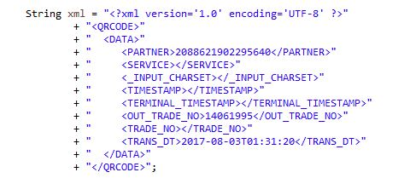

|  |  |  |  |  |
| --- | --- | --- | --- | --- |
| **STT** | **THAM SỐ** | **GIÁ TRỊ** | **BẮT BUỘC** | **CHÚ THÍCH** |
| **1** | XREF | (String) | Y | Mã giao dịch do QPAY sinh ra duy nhất, không trùng lặp (trong ngày), phục vụ đối  soát dữ liệu (Có thể trùng lặp với XREF ở trong nội dung bản tin XML) |
| **2** | User | QRCODE | Y | User của QPAY trên hệ thống của TPBank |
| **3** | Password | EB146 | Y | Password của QPAY trên hệ thống của TPBank |
| **4** | Code | QR-ALP-CANCEL | Y | Mã xử lý |
| **5** | requestData | Mô tả chi tiết bên dưới |  | Miêu tả các tham số ở dưới |
| **5.1** | PARTNER | 2088621902295640 | Y | Unique Alipay user number corresponding to authorized Alipay account number.  Composed of 16 numbers beginning with 2088. |
| **5.2** | SERVICE | alipay.acquire.cancel | Y | Interface name |
| **5.3** | TIMESTAMP | 1456507704121 | Y | Time stamp of the merchant server sending request, accurate to the millisecond. |
| **5.4** | _INPUT_CHARSET | UTF-8 | Y | Encoding format used in merchant’s website, such as  utf-8, gbk, gb2312, etc |
| **5.5** | OUT_TRADE_NO | 99003911198989 | Y | Unique order ID in Alipay’s merchant website |
| **5.6** | TERMINAL_TIMESTAMP | 1456507704102 | N | Time stamp of the terminal sending request, accurate to the millisecond. |
| **5.7** | TRADE_NO | 2013112611001004680  073956707 | N | The trade serial number of the trade in Alipay system.  16 bits at least and 64 bits at most.  If out_trade_no and  trade_no are transmitted at the same time, trade_no shall govern. |

**2. Mô tả response:**

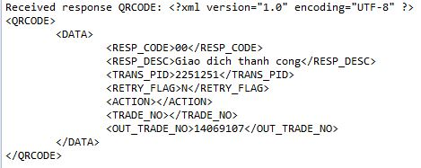

|  |  |  |  |
| --- | --- | --- | --- |
| **STT** | **THAM SỐ** | **GIÁ TRỊ** | **CHÚ THÍCH** |
| 1 | RESP_CODE |  | Mã kết quả trả về (Chi tiết mã lỗi gửi lại sau) |
| 2 | RESP_DES |  | Miêu tả kết quả |
| 3 | TRANS_PID |  | Mã giao dịch bên Paygate để đối soát. |
| 4 | OUT_TRADE_NO |  | Mã giao dịch bên Qpay để đối soát. |
| 5 | ACTION |  | The action of cancel.  Close: only closed the transaction, but no refund.  Refund: had a refund. |
| 6 | TRADE_NO |  | Trade number of the trade in Alipay system  16 bits at least and 64 bits at most |

**V.** Dịch Vụ Refund

**1. Mô ta request:**

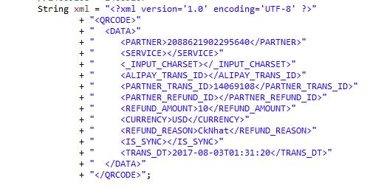

|  |  |  |  |  |
| --- | --- | --- | --- | --- |
| **STT** | **THAM SỐ** | **GIÁ TRỊ** | **BẮT BUỘC** | **CHÚ THÍCH** |
| **1** | XREF | (String) | Y | Mã giao dịch do QPAY sinh ra duy nhất, không trùng lặp (trong ngày), phục vụ đối  soát dữ liệu (Có thể trùng lặp với XREF ở trong nội dung bản tin XML) |
| **2** | User | QRCODE | Y | User của QPAY trên hệ thống của TPBank |
| **3** | Password | EB146 | Y | Password của QPAY trên hệ thống của TPBank |
| **4** | Code | QR-ALP-REFUND | Y | Mã xử lý |
| **5** | requestData | Mô tả chi tiết bên dưới |  | Miêu tả các tham số ở dưới |
| **5.1** | PARTNER | 2088621902295640 | Y | Unique Alipay user number corresponding to authorized Alipay account number.  Composed of 16 numbers beginning with 2088. |
| **5.2** | SERVICE | alipay.acquire.overseas.spot.refund | Y | Interface name |
| **5.3** | ALIPAY_TRANS_ID | 201311221703338463 | N | The Alipay transaction ID. |
| **5.4** | _INPUT_CHARSET | UTF-8 | Y | Encoding format used in merchant’s website, such as  utf-8, gbk, gb2312, etc |
| **5.5** | PARTNER_TRANS_ID | 14069108 | Y | The original partner transaction id given in the payment request |
| **5.6** | PARTNER_REFUND_ID | 301012133000002 | Y | The refund order id on partner system.  Partner_refund_id cannot be same as partner_transaction_id  partner_refund_id together with partner identify a refund transaction |
| **5.7** | REFUND_AMOUNT | 10 | Y | Less than or equal to the original transaction amount and the left transaction amount if ever refunded. |
| **5.8** | CURRENCY | USD | Y | refund currency |
| **5.9** | REFUND_REASON | Refund the good | N | The reason of refund |
| **5.10** | IS_SYNC | Y | N | The refund request is processed synchronously or asynchronously. Value: Y or N. Default value is N, which is processed asynchronously. If the value is set as Y, notify_url will become meaningless |

**2. Mô tả response:**

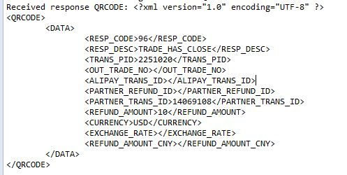

|  |  |  |  |
| --- | --- | --- | --- |
| **STT** | **THAM SỐ** | **GIÁ TRỊ** | **CHÚ THÍCH** |
| 1 | RESP_CODE |  | Mã kết quả trả về (Chi tiết mã lỗi gửi lại sau) |
| 2 | RESP_DES |  | Miêu tả kết quả |
| 3 | TRANS_PID |  | Mã giao dịch bên Paygate để đối soát. |
| 4 | OUT_TRADE_NO |  | Mã giao dịch bên Qpay để đối soát. |
| 5 | ALIPAY_TRANS_ID |  | On the partner’s payment request, the alipay system creates a transaction id to handle it.  The alipay_trans_id has one-one association with partner + partner_trans_id. |
| 6 | PARTNER_REFUND_ID |  | The refund order id on partner system.  Partner_refund_id together with partner identify a refund transaction |
| 7 | PARTNER_TRANS_ID |  | Equal to the partner_trans_id given in the request |
| 8 | REFUND_AMOUNT |  | Less than or equal to the original transaction amount and the left transaction amount if ever refunded. |
| 9 | CURRENCY |  | Refund currency |
| 10 | EXCHANGE_RATE |  | The rate of conversion the currency given in the request to CNY.  The conversion happens at the time when Alipay’s trade order is created. |
| 11 | REFUND_AMOUNT_CNY |  | Refund amount in CNY.  It is the exact amount that the Alipay has refunded. |

**VI.** Dịch Vụ Query

1. **Mô ta request:**

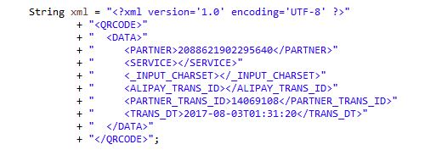

|  |  |  |  |  |
| --- | --- | --- | --- | --- |
| **STT** | **THAM SỐ** | **GIÁ TRỊ** | **BẮT BUỘC** | **CHÚ THÍCH** |
| **1** | XREF | (String) | Y | Mã giao dịch do QPAY sinh ra duy nhất, không trùng lặp (trong ngày), phục vụ đối  soát dữ liệu (Có thể trùng lặp với XREF ở trong nội dung bản tin XML) |
| **2** | User | QRCODE | Y | User của QPAY trên hệ thống của TPBank |
| **3** | Password | EB146 | Y | Password của QPAY trên hệ thống của TPBank |
| **4** | Code | QR-ALP-QUERY | Y | Mã xử lý |
| **5** | requestData | Mô tả chi tiết bên dưới |  | Miêu tả các tham số ở dưới |
| **5.1** | PARTNER | 2088621902295640 | Y | Unique Alipay user number corresponding to authorized Alipay account number.  Composed of 16 numbers beginning with 2088. |
| **5.2** | SERVICE | alipay.acquire.overseas.query | Y | Interface name |
| **5.3** | ALIPAY_TRANS_ID | 201311221703338463 | N | The Alipay transaction ID. |
| **5.4** | _INPUT_CHARSET | UTF-8 | Y | Encoding format used in merchant’s website, such as  utf-8, gbk, gb2312, etc |
| **5.5** | PARTNER_TRANS_ID | 14069108 | Y | The original partner transaction id given in the payment request |

1. **Mô tả response:**

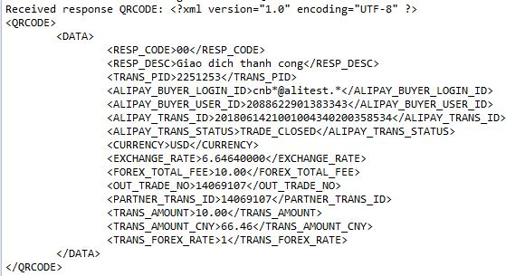

|  |  |  |  |
| --- | --- | --- | --- |
| **STT** | **THAM SỐ** | **GIÁ TRỊ** | **CHÚ THÍCH** |
| 1 | RESP_CODE |  | Mã kết quả trả về (Chi tiết mã lỗi gửi lại sau) |
| 2 | RESP_DES |  | Miêu tả kết quả |
| 3 | TRANS_PID |  | Mã giao dịch bên Paygate để đối soát. |
| 4 | OUT_TRADE_NO |  | Mã giao dịch bên Qpay để đối soát. |
| 5 | PARTNER_TRANS_ID |  | Equal to the partner_trans_id given in the request |
| 6 | ALIPAY_BUYER_LOGIN_ID |  | The buyer’s Alipay login Id, the id might be an email or mobile number.  The id is partially masked for privacy. |
| 7 | ALIPAY_BUYER_USER_ID |  | This ID stands for each Alipay account number ,unique in Alipay system start with “2088” |
| 8 | ALIPAY_TRANS_ID |  | On the partner’s payment request, the alipay system creates a transaction id to handle it.  The alipay_trans_id has one-one association with partner + partner_trans_id. |
| 9 | TRANS_AMOUNT |  | The transaction amount in the currency given above;  Range: 0.01-100000000.00. Two digits after decimal point. |
| 10 | EXCHANGE_RATE |  | The rate of conversion the currency given in the request to CNY.  The conversion happens at the time when Alipay’s trade order is created. |
| 11 | TRANS_AMOUNT_CNY |  | Transaction amount in CNY.  It is the exact amount that the buyer has paid |
| 12 | ALIPAY_TRANS_STATUS |  | WAIT_BUYER_PAY,  TRADE_SUCCESS,  TRADE_CLOSED |
| 13 | FOREX_TOTAL_FEE |  |  |
| 14 | TRANS_FOREX_RATE |  |  |
| 15 | CURRENCY |  |  |